**MAHARASHTRA STATE BOARD OF TECHNICAL EDUCATION , MUMBAIGovernment polytechnic , washim   
Subject :- programing in c  
A PROJECT REPORT ON :-  
Generate a salary slip of employees of a company**



**CERTIFICATE**

**This is to certify that the group name of student**

|  |  |  |
| --- | --- | --- |
| **CANDIDATE NAME** | **ROLL NO** | **ENROLLMENT NO** |
| **LEENA RAJESHWAR KALE** | **26** | **2000310221** |
| **SAKSHI SANJAY RAGAD** | **51** | **2000310246** |
| **ISHA MANOJKUMAR RAUT** | **54** | **2000310249** |
| **SHRUNGI VIJAY SARODE** | **56** | **2000310251** |

**First year student of information technology has submitted a micro project report on**

**“Generate a salary slip of employees of a company”**

**During the academic session 2020-2021 in a satisfactory manner in the partial fulfillment for the requirement for the diploma in**

**“ information technology ” awarded by**

**Maharashtra state board of technical education , Mumbai**

**Guided by H.O.D Principal**

**Prof. Udaysingh Bagade Prof. Udaysingh Bagade Dr. V. R. Mankar**

**( lecture in Info .Tech Department ) ( Info .Tech Department ) ( Info .Tech Department ) (Government Polytechnic , Washim)**

**2020-2021**

**SUBMITTED BY :**

|  |  |  |
| --- | --- | --- |
| **CANDIDATE NAME** | **ROLL NO** | **ENROLLMENT NO** |
| **LEENA RAJESHWAR KALE** | **26** | **2000310221** |
| **SAKSHI SANJAY RAGAD** | **51** | **2000310246** |
| **ISHA MANOJKUMAR RAUT** | **54** | **2000310249** |
| **SHRUNGI VIJAY SARODE** | **56** | **2000310251** |

***GUIDED BY :-* UDAYSINGH BAGADE SIR**

**PRINCIPLE NAME :- Dr. V.R.MANKAR**

**Index**

|  |  |  |
| --- | --- | --- |
| **Sr.no.** | **Name of topic** | **Page no.** |
| **1** | **Program** | **5** |
| **2** | **Output** | **6** |
| **3** | **conclusion** | **8** |

PROGRAM

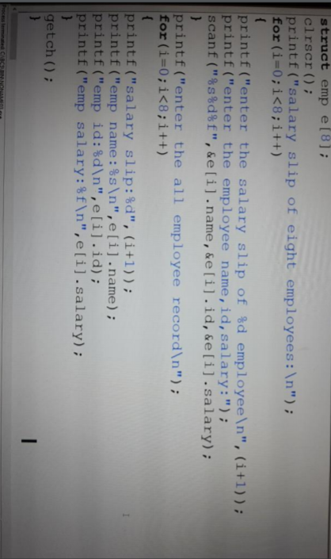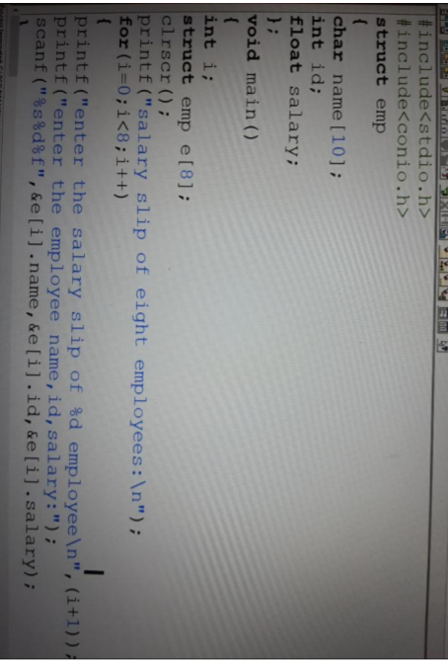

OUTPUT :-

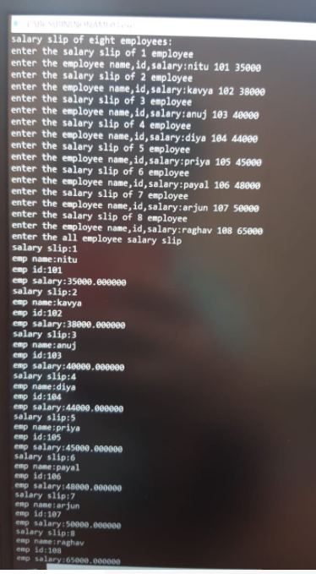

**Conclusion:-**

On a concluding note , it can be ascertained that arrays are a simple and efficient way to store , organize and manipulate data of the same type through indexing without using repetitive variable names.

We have also observed that arrays are present in the memory as contiguous blocks of data and thus, the data can be extracted from the indices using pointers as well.

Thank you…